# VISVESVARAYA TECHNOLOGICAL UNIVERSITY

### “Jnana Sangama”, Machhe, Belagavi, Karnataka-590018



An Internship Report

*On*

**MODELING OF DC MOTOR FOR EV USING MATLAB AND SIMULINK**

***Submitted in partial fulfillment of the requirements for the award of the degree of***

### Bachelor of Engineering

In

### Electrical & Electronics Engineering

***Submitted By***

### CHANDANA J (4GW19EE008)

***at***

### LARSEN & TOUBRO LIMITED, MYSORE

**Under the guidance of**

Internal Guide: **Ashwini K R Asst. Professor EEE Department**

External Guide:

### Mr.Sujit V

**Director General Manager Larsen & Toubro Limited,Mysore**



### DEPARTMENT OF ELEECTRICAL &ELECTRONICS ENGINEERING GSSS INSTITUTE OF ENGINEERING &TECHNOLOGY FOR WOMEN

**(Affiliated to VTU, Belagavi, Approved by AICTE, New Delhi & Govt. of Karnataka)**

**K.R.S ROAD, METAGALLI, MYSURU-570016, KARNATAKA**

**Accredited with Grade “A” by NAAC- 2022**

Geetha Shishu Shikshana Sangha (R)

### GSSS INSTITUTE OF ENGINEERING & TECHNOLOGY FOR WOMEN

**K.R.S Road, Mysuru-570016, Karnataka**

(Affiliated to VTU, Belagavi, Approved by AICTE -New Delhi & Govt. of Karnataka)

**Accredited with Grade ‘A’ by NAAC**

**DEPARTMENT OF ELECTRICAL AND ELECTROINICS ENGINEERING**

**(B.E (E&E) program Accredited by NBA, New Delhi, validity from 01.06.2021 to 30.06.2024)**

### CERTIFICATE

Certified that the 7th Semester Internship titled **“MODELING OF DC MOTOR FOR EV USING MATLAB AND SIMULINK”** is a bonafide work carried out by **CHANDANA.J (4GW19EE008)** inpartial fulfillment for the award of degree of bachelor of engineering in **Department of Electrical & Electronics Engineering** of the Visvesvaraya Technological University, Belagavi, during the year 2022-23. The internship report has been approved as it satisfies the academic requirements with respect to the Internship work prescribed for Bachelor of Engineering Degree.

|  |  |
| --- | --- |
| **Ashwini K R** | **Dr. G Sreeramulu Mahesh** |
| Asst.Professor | Professor and Head |
| Department of EEE | Department of EEE |

|  |  |
| --- | --- |
| **Examiner 1** | **Examiner 2** |
| **Name:** |  |
| **Signature** |  |

### ACKNOWLEDGEMENT

The joy and satisfaction that accompany the successful completion of any task would be incomplete without the mention of the people who made it possible.

First and foremost I offer my sincere phrases of thanks to **Smt**. **Vanaja B Pandit,** Hon. Secretary, GSSSIETW and the management of GSSSIETW, Mysuru for providing help and support to carry out the internship.

I would like to express my gratitude to our Principal**, Dr. Shivakumar M** for providing a congenial environment for engineering studies and also for having showed me the way to carry out the internship.

I consider it a privilege and honour to express my sincere thanks to **Dr. G Sreeramulu Mahesh** Professor and Head, Department of Electrical & Electronics Engineering for his support and invaluable guidance throughout the tenure of this project.

I would like to thank my External Guide Sri. **SUJIT.V** Director General Manager, Larsen & Toubro Ltd. for his support, guidance, motivation, encouragement for the successful completion of this internship.

I would like to thank my Guide **Ashwini K R** Asst. Professor, Department of Electrical &Electronics Engineering for his support, guidance, motivation, encouragement for the successful completion of this internship.

I intend to thank all the teaching and non-teaching staffs of my Department of Electrical & Electronics Engineering for their immense help and co-operation.

Finally I would like to express my gratitude to my parents and friends who always stood by me. Thank you.

**CHANDANA J (4GW19EE008)**

### ACKNOWLEDGEMENT

The joy and satisfaction that accompany the successful completion of any task would be incomplete without the mention of the people who made it possible.

First and foremost I offer my sincere phrases of thanks to **Smt**. **Vanaja B Pandit,** Hon. Secretary, GSSSIETW and the management of GSSSIETW, Mysuru for providing help and support to carry out the internship.

I would like to express my gratitude to our Principal**, Dr. Shivakumar M** for providing a congenial environment for engineering studies and also for having showed me the way to carry out the internship.

I consider it a privilege and honour to express my sincere thanks to **Dr. G Sreeramulu Mahesh** Professor and Head, Department of Electrical & Electronics Engineering for his support and invaluable guidance throughout the tenure of this project.

I would like to thank my External Guide Sri. **SUJIT.V** Director General Manager, Larsen & Toubro Ltd. for his support, guidance, motivation, encouragement for the successful completion of this internship.

I would like to thank my Guide **Ashwini K R** Asst. Professor, Department of Electrical &Electronics Engineering for his support, guidance, motivation, encouragement for the successful completion of this internship.

I intend to thank all the teaching and non-teaching staffs of my Department of Electrical & Electronics Engineering for their immense help and co-operation.

Finally I would like to express my gratitude to my parents and friends who always stood by me. Thank you.

**CHANDANA J (4GW19EE008)**

## ABSTRACT

The speed control of a separately excited dc motor “A separately excited DC motor has a regulated or unregulated power supply that supplies power to the field winding that is completely independent from the power supplied to the armature”. Conventional controllers are generally used to control the speed of the separately excited DC motors in various industrial applications. It is found to be simple and high effective if the load disturbances are small. So there will be drawback of Conventional controllers when high load has been applied to the DC motor.

The system has been implemented using MATLAB/Simulink software. The simulations results show that presenting controller give good performance and high robustness in load disturbance. Separately excited DC motor has been done & Transfer Function has

been derived with simulated result.

# CONTENTS

|  |  |  |
| --- | --- | --- |
| **CERTIFICATE** |  |  |
| **ACKNOWLEDGEMENT** |  | i |
| **ABSTRACT** |  | ii |
| **CONTENTS** |  | iii |
| **LIST OF FIGURES** |  | iv |
| **Chapter 1** | **Introduction** | **1-4** |
|  | 1.1 Separately Excited DC Motor | 1 |
|  | 1.2 MATLAB | 3 |
|  | 1.3 Simulink | 4 |
| **Chapter 2** | **Modelling of separately excited DC Motor** | **5-8** |
|  | 2.1 Physical System | 5 |
|  | 2.2 The physical parameters of separately excited DC Motor | 5 |
|  | 2.3 System equation | 6 |
|  | 2.4 State Space | 7 |
|  | 2.5 Laplace transform expression | 7 |
|  | 2.6 Design requirements | 8 |
| **Chapter 3** | **MATLAB Representation** | **9-10** |
|  | 3.1 Transfer function | 9 |
|  | 3.2 Program | 9 |
| **Chapter 4** | **Building the model with Simulink** | **11-15** |
| **Chapter 5** | **DC Motor Speed: Simulink controller design** | **16-20** |
|  | 5.1 Extracting linear model into MATLAB | 16 |
|  | 5.2 Open loop step response | 18 |
|  | 5.3 Conclusion | 20 |
| **REFERENCES** |  | **21** |

## List of Figures

|  |  |  |
| --- | --- | --- |
| **Figure No** | **Title** | **Page No.** |
| 1.1 | DC Motor | 1 |
| 1.2 | Separately excited DC Motor | 2 |
| 2.1 | Free body diagram of armature DC motor | 5 |
| 3.1 | Code in command window | 9 |
| 3.2 | Plot obtained | 10 |
| 4.1 | Insertion of integral block | 11 |
| 4.2 | Formation of equation in Simulink model | 12 |
| 4.3 | Formation of equation | 13 |
| 4.4 | Final design of model | 14 |
| 4.5 | Single system block | 15 |
| 4.6 | Graph obtained by Simulink | 15 |
| 5.1 | Developed Simulink model | 16 |
| 5.2 | DC Motor Model | 17 |
| 5.3 | Open loop step response | 17 |
| 5.4 | DC Motor model | 19 |

**CHAPTER 1**

## INTRODUCTION

A DC motor is an electromechanical energy converter which converts electrical energy into mechanical energy. It is often used as an actuator in control systems. The DC motor acts as an energy conversion actuator that converts electrical energy (of source) into mechanical energy (for load). When a DC motor is powered, a magnetic field is created in its stator. The field attracts and repels magnets on the rotor; this causes the rotor to rotate. To keep the rotor continually rotating, the commutator that is attached to brushes connected to the power source supply current to the motors wire windings.

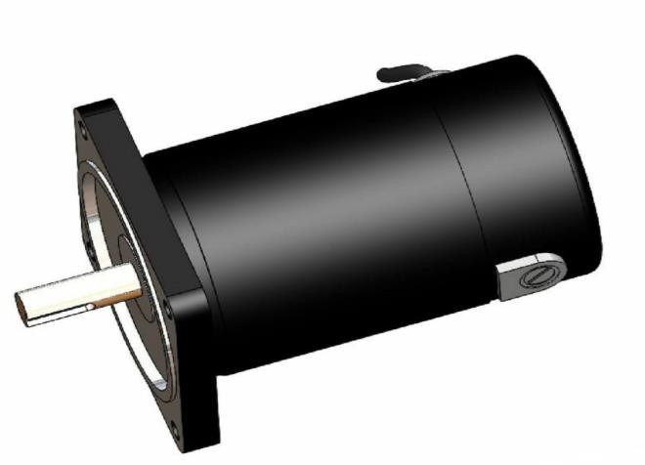

Figure 1.1: DC MOTOR

One of the reasons DC motors are preferred over other types of motors is their ability to precision control their speed, which is a necessity for industrial machinery. DC motors are able to immediately start, stop, and reverse—an essential factor for controlling the operation of production equipment.

### Separately Excited DC Motor

In a separately excited DC motor, the motor has separate electrical supplies to the armature winding and field winding, which are electrically separate from each other. The operations of the armature current and field current do not interfere with each other ‘s actions, but the input power is their total sum.

DC motor is the motor that first appeared and is the earliest that can realize speed regulating motor. Separately excited motor is a kind of dc motor, its characteristic is exciting winding and armature winding consists of two power supply respectively, more controllable parameters, easy to

realize the need for mechanical properties, has a wide speed range and environmental protection, and efficient characteristics, widely used in some host drive system, at present is also applied to electric cars.

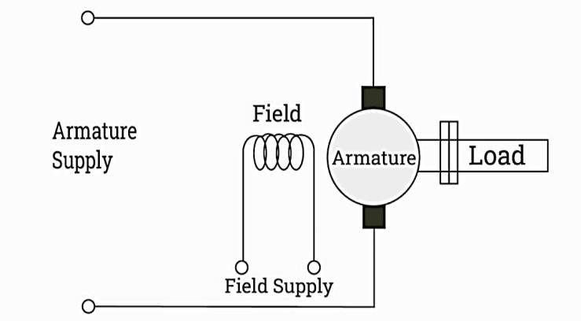

Figure 1.2 : Seperately exicted DC Motor

The separately excited motors have wide application in automobile traction applications. The growing demand for vehicles is likely to create the demand for separately excited motors for automotive traction applications during the forecast period. The food, cosmetics, and consumer goods companies are working with paper manufacturers for developing packaging solutions to meet the sustainability goals which is propelling the demand for separately excited motors. The separately excited motors find large applications automobile industry such as in Automotive Traction Application. The technological upgrades, new product development in the vehicles is fueling the demand for vehicles. Thus, the use of separately excited has been increased in automotive traction application. Furthermore, due to rising demand for electric vehicles the automobile manufacturing companies are expanding their capacities by investing in different geographical locations.

It is popular in the European and American countries and has been applied in our country is less, but because of its environmental protection, efficient excellence also pays close attention to buy more and more, the domestic companies abroad controller are adopted in the production of electric cars, the performance is better, but the price is expensive, some companies are domestic production controller, but the performance is not so good. Therefore, to design a general separately excited motor controller to control, and can in a complex environment, according to the parameters of different motor.

These motors are extensively applied for robotic manipulations, cutting tools, electrical tractions, etc. The torque-speed characteristics of DC motors are most compatible with most

mechanical loads. Hence DC motors are always a good ground for advanced control algorithm. The control characteristics of these motors have resulted to their immense use and hence control of their speed is required. Speed of a DC motor depends on supply voltage, armature resistance and field flux produced by the field current. The methods to control speed of these motors are armature voltage control, armature resistance control and field flux control. The parameters of the PID controller Kp, Ki, and Kd (or Kp, Ti and Td) can be manipulated to produce various response curves from a given process.

### MATLAB

MATLAB is a programming platform designed specifically for engineers and scientists to analyse and design systems and products that transform our world. The heart of MATLAB is the MATLAB language, a matrix-based language allowing the most natural expression of computational mathematics.

MATLAB/Simulink software is a tool capable of modelling complete EV powertrains of different levels of fidelity and detail and has become an invaluable modelling platform. This software features a variety of shipped sample models for simulation of pure battery electric as well as hybrid electric vehicles of different configurations and types. The MATLAB/Simulink platform supports many add-ons which have been used in vehicle modelling, such as Sim Power Systems and Sim Driveline, Advisor, Sim scape, Powertrain Block set, etc. Simulink supports an equation-based modelling approach, a data driven modelling approach, as well as a physical modelling approach for vehicle modelling. Simulink also supports code generation for hardware testing and deployment, testing and analysis frameworks for test case management and report generation.

### Features of MATLAB

* + - * It is a high-level language for numerical computation, visualization and application development.
      * It also provides an interactive environment for iterative exploration, design and problem solving.
      * It provides vast library of mathematical functions for linear algebra, statistics, Fourier analysis, filtering, optimization, numerical integration and solving ordinary differential equations.
      * It provides built-in graphics for visualizing data and tools for creating custom plots.
      * MATLAB's programming interface gives development tools for improving code quality maintainability and maximizing performance.
      * It provides tools for building applications with custom graphical interfaces.
      * It provides functions for integrating MATLAB based algorithms with external applications and languages such as C, Java, .NET and Microsoft Excel.

### Simulink

Simulink is a software package for modelling, simulating, and analyzing dynamic systems. It supports linear and nonlinear systems, modelled in continuous time, sampled time, or a hybrid of the two. Systems can also be multi rate, i.e., have different parts that are sampled or updated at different rates.

Simulink provides a graphical editor, customizable block libraries, and solvers for modeling and simulating dynamic systems. It is integrated with MATLAB®, enabling you to incorporate MATLAB algorithms into models and export simulation results to MATLAB for further analysis.

### Features of Simulink

* + - * Graphical editor for building and managing hierarchical block diagrams
      * Libraries of predefined blocks for modeling continuous-time and discrete-time systems
      * Simulation engine with fixed-step and variable-step ODE solvers
      * Scopes and data display for viewing simulation results
      * Project and data management tools for managing model files and data
      * Model analysis tools for refining model architecture and increasing simulation speed
      * MATLAB Function block for importing MATLAB algorithms into models
      * Legacy Code Tool for importing C and C++ code into models

**CHAPTER 2**

## MODELLING OF SEPARATELY EXCITED DC MOTOR

As the DC motor model is implemented by mathematical expression. This implemented model is analyzed by techniques of time domain and frequency domain analysis in MATLAB simulation.

### Physical System

A common actuator in control systems is the DC motor. It directly provides rotary motion and, coupled with wheels or drums and cables, can provide translational motion. The electric equivalent circuit of the armature and the free-body diagram of the rotor are shown in the following figure.

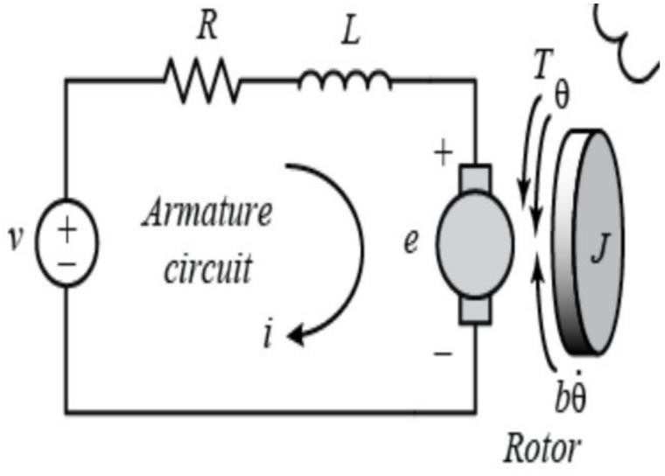

Figure 2.1: Free body diagram of armature of a DC motor

The basic equations of a DC motor (electric part) are obtained from Maxwell's electromagnetic theory. For this example, assume that the input of the system is the voltage source (V) applied to the motor's armature, while the output is the rotational speed of the shaft dθ/dt. The rotor and shaft are assumed to be rigid. Further assume a viscous friction model, ie., the friction torque is proportional to shaft angular velocity.

### The Physical Parameters of separately excited dc motor

* + - Ra=Armature Resistance
    - La=Armature self-inductance caused by armature flux
    - Ia= Armature current
    - if= field current
    - Eb=Back EMF in armature
    - V =Applied voltage
    - T=Torque developed by the motor
    - θ = Angular displacement of the motor shaft
    - Ј =Equivalent moment of inertia of motor shaft & load referred to the motor
    - B= Equivalent Coefficient of friction of motor shaft & load referred to the motor

### System Equation

In general, the torque generated by a DC motor is proportional to the armature current and the strength of the magnetic field. In this example we will assume that the magnetic field is constant and, therefore, that the motor torque is proportional to only the armature current i by a constant factor

𝐾𝑡 is given by equation 2.1.

𝑇 =∗ 𝑖 --------------2.1

The back emf, ‘e’ is proportional to the angular velocity of the shaft, it is represented as constant factor 𝐾𝑒.

𝑒 = 𝐾𝑒 ∗ 𝜃 --------------2.2

In SI units, the motor torque and back emf constants are equal,.

𝐾𝑡 = 𝐾𝑒 --------------2.3

Therefore, we will use ‘K’ to represent both the motor torque constant and the back emf constant. From the figure 2.1, w governing equations based on Newton's 2nd law and Kirchhoff's voltage law is given equation 2.4

𝐽𝜃 + 𝑏𝜃 = 𝐾 ∗ 𝑖 --------------2.4

L𝑑𝑖 + 𝑅𝑖 = 𝑉 − 𝐾θ 2.5

𝑑𝑡

Where

J→ moment of inertia Kg/m3 b→ friction coefficient,

L→ inductance in Henries

R→ armature resistance in Ohms, V→ Input voltage volts

K→ electromotive force constant,

θ → angular acceleration.

### State Space

In state-space form, the governing equations above can be expressed by choosing the rotational speed and electric current as the state variables. Again, the armature voltage is treated as the input and the rotational speed is chosen as the output.

𝑑 𝜃

− 𝑏

𝐽

𝐾

𝐽 𝜃 0

1

𝑑𝑡 [ 𝑖 ] = [− 𝐾

𝐿

− 𝑅] [ 𝑖 ] + [

𝐿

𝐿

]V 2.6

y = [1 0] [𝜃] 2.7

𝑖

Where,

− 𝑏 𝐾 0

A= [ 𝐽 𝐽 ] , B = [1 ] , C = [1 0] , D=0 2.8

− 𝐾

𝐿

− 𝑅 𝐿

𝐿

### Laplace Transform Expression

LTI systems have the extremely important property that if the input to the system is sinusoidal, then the output will also be sinusoidal at the same frequency but in general with different magnitude and phase. These magnitude and phase differences as a function of frequency are known as the frequency response of the system.

Using the Laplace transform, it is possible to convert a system's time-domain representation into a frequency domain output/input representation, known as the transfer function. In so doing, it also transforms the governing differential equation into an algebraic equation which is often easier to analyze.

Applying the Laplace transform, the above modeling equations can be expressed in terms of the Laplace variable s.

S[J(s)+b] θ(s) = KI(s) 2.9

[L(s)+R] I(s) = V(s)-Ks θ(s) 2.10

Here Laplace operator θ(s) represents the angular displacement in s domain. From Equation (2.10) I(s) is given as(Equation 2.11)

I(s) = V(s)−𝐾𝑠 𝜃(𝑠)

𝑅+𝑠𝐿

Then substituted in Equation (2.9) to obtain

Js2 (θ)s + bsθ(s)= KV(s)−Ks θ(s)

R+sL

--------------2.11

--------------2.12

The following open-loop transfer function is arrived by eliminating I(s) between the two above equations, where the rotational speed is considered the output and the armature voltage is considered the input.

Wv(s) ω (s)

V(s)

= K

(Js+b)(Ls+R)+K^2

[rad/sec] 2.13

V

From equation 2.12, the transfer function the ratio of 𝜃(𝑠) to voltage V(s)) is:

W𝜃(s) θ (s)

V(s)

= K

(𝑠(Js+b)(Ls+R)+K^2)

[rad/sec] 2.14

V

### Design Requirements

First consider that our uncompensated motor rotates at 0.1 rad/sec in steady state for an input voltage of 1 Volt. Since the most basic requirement of a motor is that it should rotate at the desired speed, So that the steady-state error of the motor speed be less than 1%. Another performance requirement for motor is that it must accelerate to its steady-state speed as soon as it turns on. In this case, settling time should be less than 2 seconds. Since a speed faster than the reference may damage the equipment, So that a step response with overshoot should be less than 5%.

In summary, for a unit step command in motor speed, the control system's output should meet the following requirements.

* + - Settling time less than 2 seconds
    - Overshoot less than 5%
    - Steady-state error less than 1%

**CHAPTER 3**

## MATLAB REPRESENTATION

### Transfer Function

The open-loop transfer function of the motor in MATLAB by defining the parameters and transfer function as follows. Running this code in the command window produces the output shown below. First create a new [m-file](https://ctms.engin.umich.edu/CTMS/index.php?aux=Extras_Mfile) and type in the following commands

### Program:

J=0.02; b=0.1; K=0.03; R=1; L=0.5;

s = tf('s');

P_motor = K/((J*s+b)*(L*s+R)+K^2);

Add the following linear System Analyzer command onto the end of the m-file and run it in the MATLAB command window. Access the Linear System Analyzer also by going to the APPS tab of the MATLAB toolstrip and clicking on the app icon under Control System Design and Analysis. In the command below, the string 'step' passed to the function specifies to generate a unit step response plot for the system P_motor. The range of numbers 0:0.1:5 specify that the step response plot should include data points for times from 0 to 5 seconds in steps of 0.1 seconds. The resulting plot is shown in the figure below, where view of some of the system's characteristics by right-clicking on the figure and choosing from the Characteristics menu such performance aspects as Settling Time and Steady State. “**linearSystemAnalyzer('step', P_motor, 0:0.1:5)”**

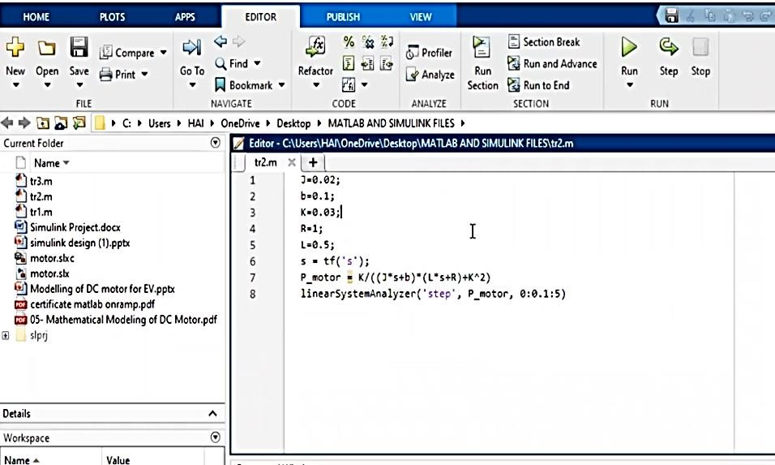

Figure 3.1 : code in the command window

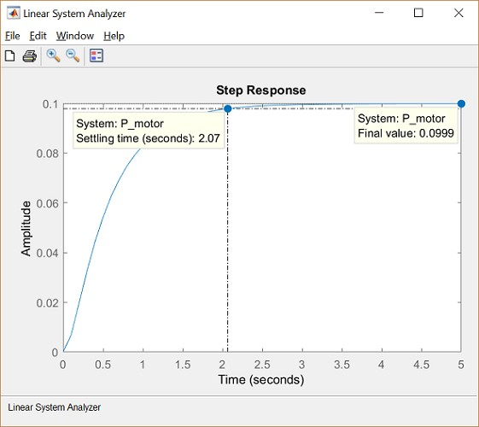

Figure 3.2 : Plot obtained

Figure 3.2 shows plot obtained after simulation of the program. From the plot it is observed that 1 Volt is applied to the system the motor can only achieve a maximum speed of 0.1 rad/sec. Also, it takes the motor 2.07 seconds to reach its steady-state speed.

**CHAPTER 4**

## BUILDING THE MODEL WITH SIMULINK

This system will be modeled by summing the torques acting on the rotor inertia and integrating the acceleration to give velocity. Also, Kirchhoff’s laws will be applied to the armature circuit. First, model the integrals of the rotational acceleration and the rate of change of the armature current is by equation 4.1

∫ 𝑑2𝜃 𝑑𝑡 = 𝑑𝜃

--------------4.1

𝑑𝑡2

𝑑𝑡

∫ 𝑑𝑖 dt = I 4.2

𝑑𝑡

To build the simulation model, open Simulink and then open a new model window. Then follow the steps listed below.

* Insert an Integrator block from the Simulink/Continuous library and draw lines from its input and output terminals.
* Label the input line "d2/dt2(theta)" and the output line "d/dt(theta)" as shown below. To add such a label, double-click in the empty space just below the line.
* Insert another Integrator block above the previous one and draw lines from its input and output terminals.
* Label the input line “𝑑⁄𝑑𝑡 (𝑖)” and the output line "i".

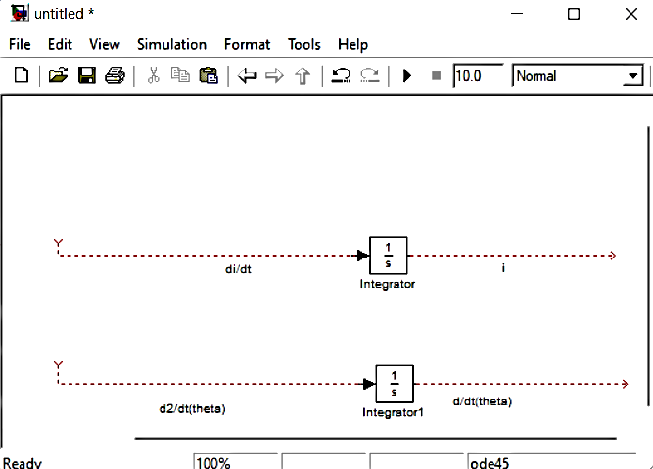

Figure 4.1: Insertion of integral block

Apply Newton's law and Kirchhoff’s law to the motor system to generate the following equations

**J**𝒅𝟐𝜃 = 𝑻 − 𝒃 𝒅𝜃 𝒅𝟐𝜃 = 𝟏**(Kt*i -** 𝒃 𝒅𝜃**)**

𝒅𝒕𝟐

𝒅𝒕

𝒅𝒕𝟐 𝑱

𝒅𝒕

***L***𝒅𝐢 = −𝐑𝐢**+V-e** 𝒅𝐢 = 𝟏 **(-Ri+V-**𝑲𝒆 𝒅𝜃 **)**

𝒅𝒕

𝒅𝒕 𝑳

𝒅𝒕

The angular acceleration is equal to 1/J multiplied by the sum of two terms (one positive, one negative). Similarly, the derivative of current is equal to 1/L multiplied by the sum of three terms (one positive, two negative). Continuing to model these equations in Simulink, follow the steps given below.

* Insert two Gain blocks from the Simulink/Math Operations library, one attached to each of the integrators.
* Edit the Gain block corresponding to angular acceleration by double-clicking it and changing its value to "1/J".
* Change the label of this Gain block to "Inertia" by clicking on the word "Gain" underneath the block.
* Similarly, edit the other Gain's value to "1/L" and its label to "Inductance".
* Insert two Add blocks from the Simulink/Math Operations library, one attached by a line to each of the Gain blocks.
* Edit the signs of the Add block corresponding to rotation to "+-" since one term is positive and one is negative.
* 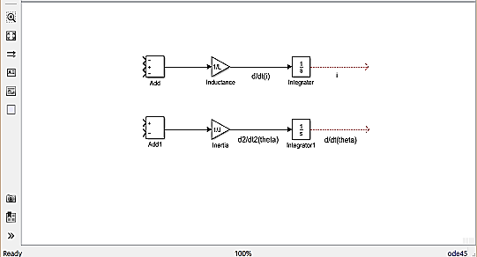Edit the signs of the other Add block to "-+-" to represent the signs of the terms in the electrical equation.

Figure 4.2: Formation of equation in Simulink model

Now, add in the torques which are represented in the rotational equation. First, add the damping torque.

* Insert a Gain block below the "Inertia" block. Next right-click on the block and select **Rotate & Flip > Flip Block** from the resulting menu to flip the block from left to right. This can also flip a selected block by holding down **Ctrl-I**.
* Set the Gain value to "b" and rename this block to "Damping".
* Tap a line (hold **Ctrl** while drawing or right-click on the line) off the rotational Integrator's output and connect it to the input of the "Damping" block.
* Draw a line from the "Damping" block output to the negative input of the rotational Add block.

Next, add the torque from the armature.

* Insert a Gain block attached to the positive input of the rotational Add block with a line.
* Edit its value to "K" to represent the motor constant and Label it "Kt".
* Continue drawing the line leading from the current Integrator and connect it to the "Kt" block.

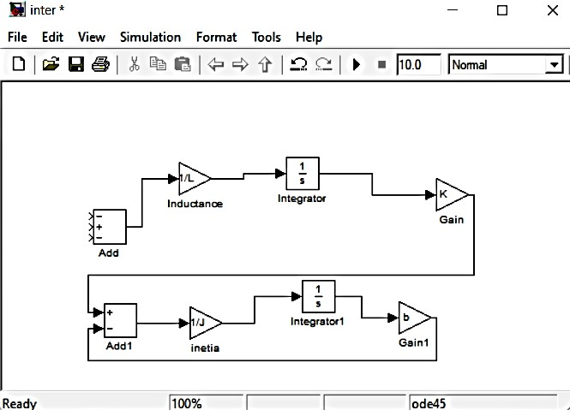

Figure 4.3 : Formation of equation

Now, add the voltage terms which are represented in the electrical equation. First, add the voltage drop across the armature resistance.

* Insert a Gain block above the "Inductance" block and flip it from left to right.
* Set the Gain value to "R" and rename this block to "Resistance".
* Tap a line off the current Integrator's output and connect it to the input of the "Resistance" block.
* Draw a line from the "Resistance" block's output to the upper negative input of the current equation Add block.

Next, add the back emf from the motor.

* Insert a Gain block attached to the other negative input of the current Add block with a line.
* Edit its value to "K" to represent the motor back emf constant and Label it as "Ke".
* Tap a line off the rotational Integrator's output and connect it to the "Ke" block.
* Add In1 and Out1 blocks from the Simulink/Ports & Subsystems library and respectively label them "Voltage" and "Speed".

The final design should look like the example shown in the figure 4.4 .

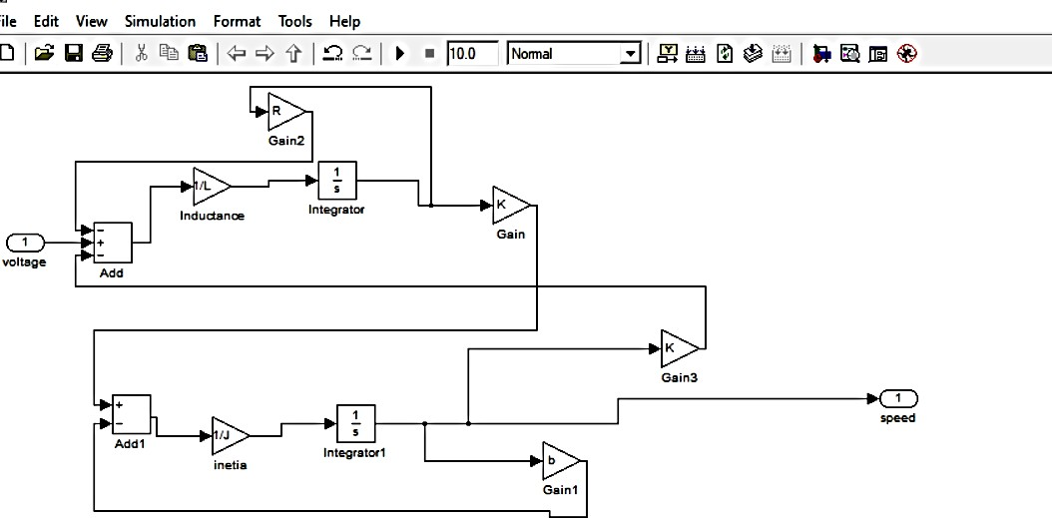

Figure 4.4 : Final design of model

In order to save all of these components as a single subsystem block, first select all of the blocks, then select **Create Subsystem from Selection** after right-clicking on the selected portion. Name the subsystem "DC Motor" and then save the model. Your model should appear as follows.

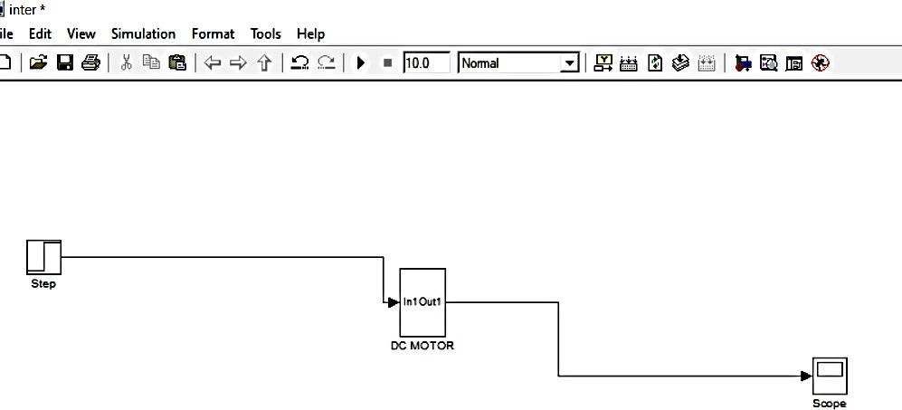

Figure 4.5 Single subsystem block

Assign the paramater values to the required components and get the output.

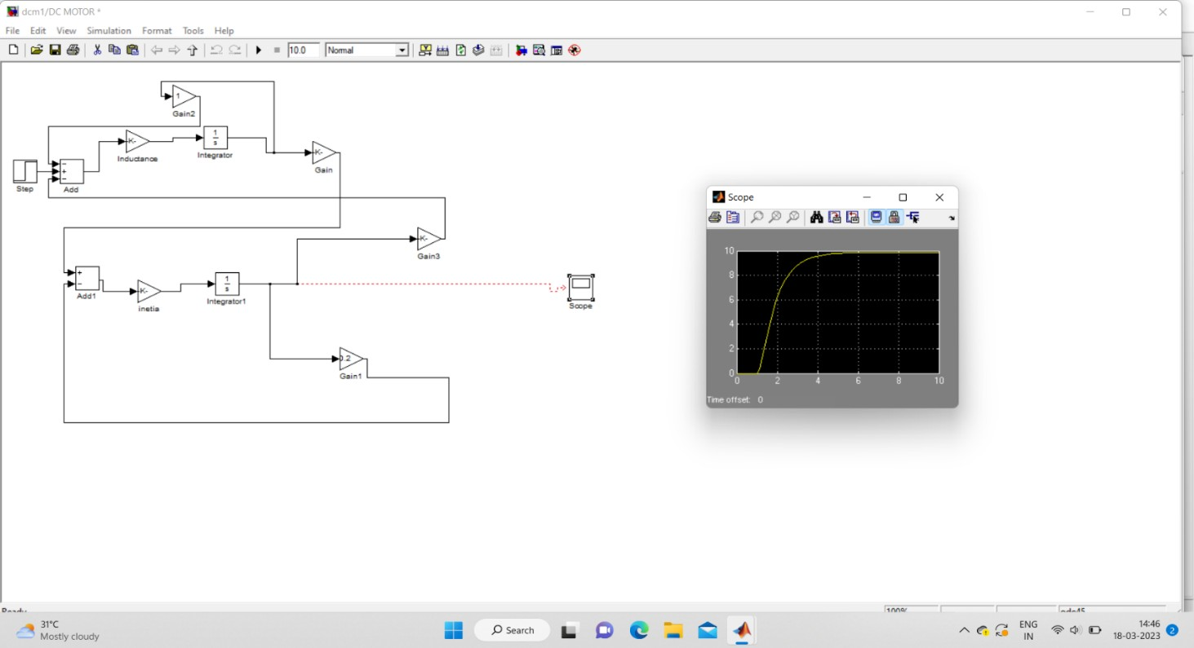

Figure 4.6: Simulink result

Figure 4.6 : graph obtained by simulink which is similar to the MATLAB result.

**CHAPTER 5**

## DC MOTOR SPEED: SIMULINK CONTROLLER DESIGN

### Extracting linear model into MATLAB

A linear model of the system can be extracted from the Simulink model into the MATLAB workspace. This can be accomplished by employing the MATLAB command linmod or from directly within Simulink. Then specifically use the base Simulink model developed from first principles shown below.

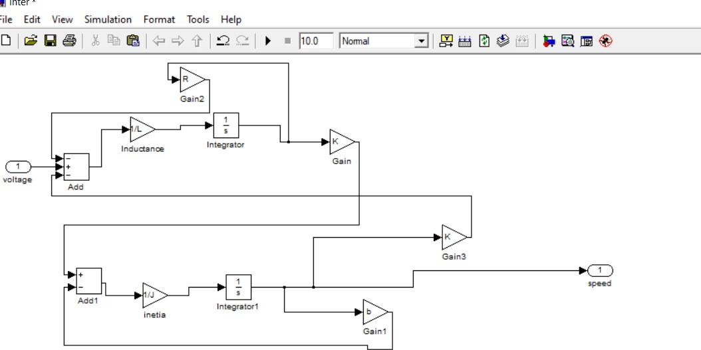

Figure 5.1 : Developed Simulink Model

The physical parameters have to be set if they have not previously been defined in the workspace. J = 0.01;

b = 0.1;

K = 0.01;

R = 1;

L = 0.5;

Then identify the inputs and outputs of the model to extract. First right-click on the signal representing the Voltage input in the Simulink model. Then choose **Linear Analysis Points > Open- loop Input** from the resulting menu. Similarly, right-click on the signal representing the Speed output and select **Linear Analysis Points > Open-loop Output** from the resulting menu. The input and output signals should now be identified on the model by arrow symbols as shown in the figure below.

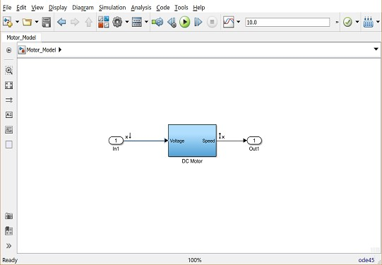

Figure 5.2 : DC Motor Model

In order to perform the extraction, select from the menu at the top of the model window **Analysis > Control Design > Linear Analysis**. This will cause the **Linear Analysis Tool** to open. Within the **Linear Analysis Tool** window, the **Operating Point** to be linearized about can remain the default, Model Initial Condition. In order to perform the linearization, next click the **Step** button identified by a step response with a small green triangle. The result of this linearization is the linsys1 object which will appear in the **Linear Analysis Workspace** as shown below. Furthermore, the open-loop step response of the linearized system also will be generated automatically.

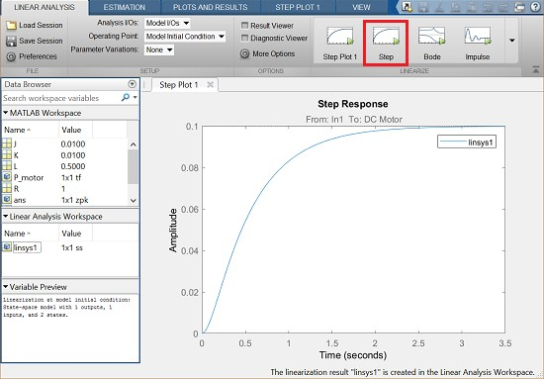

Figure 5.3: Open loop step response

The reason that responses match so closely is because this Simulink model uses only linear components. Note that this process can be used to extract linear approximations of models with nonlinear elements too.

To further verify the model extraction can be done by looking at the model itself. The linearized model can be exported by simply dragging the object into the MATLAB Workspace. This object can then be used within MATLAB in the same manner as an object created directly from the MATLAB command line. Specifically, entering the command zpk(linsys1) in the MATLAB command window demonstrates that the resulting model has the following form.

P(s) = 𝜃(𝑠) = 2 [𝑟𝑎𝑑/𝑠𝑒𝑐] 5.1

𝑉(𝑆) (𝑠+9.997)(𝑠+2.003) 𝑉

This can be seen by repeating the MATLAB commands given below. s=tf('s');

P_motor = K/((J*s+B)*(L*s+R)+K2); zpk(P_motor)

Answer: = 2

(𝑠+9.997)(𝑠+2.003)

Continuous-time zero/pole/gain model.

### Open-Loop Step Response

The open-loop step response can also be generated directly within Simulink, without extracting any models to the MATLAB workspace. In order to simulate the step response, the details of the simulation must be first set. This can be accomplished by selecting Model Configuration Parameters from the Simulation menu. Within the resulting menu, define the length for which the simulation is to run in the Stop time field. Then enter "3" since 3 seconds will be long enough for the step response to reach steady state.

Within this window, can also specify various aspects of the numerical solver, but use the default values for this example.

* + - Next add an input signal for displaying the output of our simulation. This is done by doing the following:
    - Remove the In1 and Out1 blocks.
    - Insert a Step block from the Simulink/Sources library and connect it with a line to the Voltage input of the motor subsystem.
    - To view the Speed output, insert a Scope from the Simulink/Sinks library and connect it to the Speed output of the motor subsystem.
    - 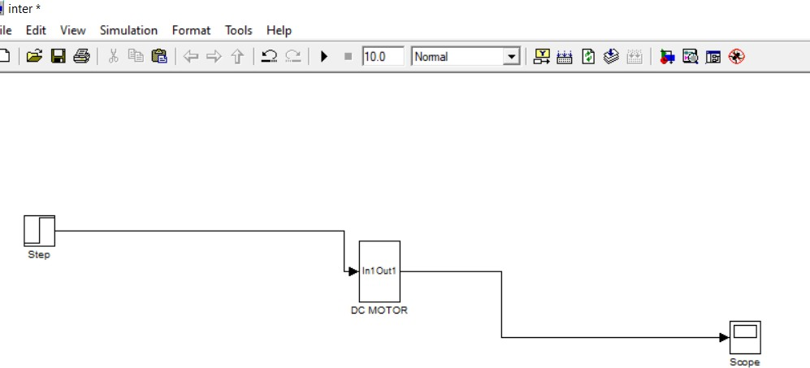To provide an appropriate unit step input at t=0, double-click the Step block and set the **Step time** to "0". The final model should appear as shown in the following figure 5.4

Figure 5.4 : DC Motor Model

Then run the simulation (press Ctrl-T or select Run from the Simulation menu). When the simulation is finished, double-click on the scope and output will be obtained.

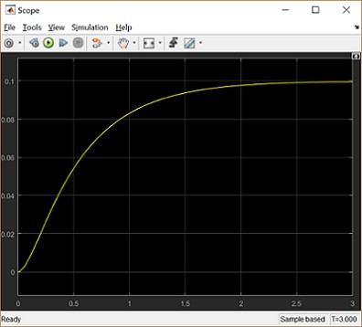

Figure 5.5 : Output Response

This response is identical to that obtained by MATLAB above using the extracted model. This is again to be expected because this Simulink model includes only linear blocks.

### CONCLUSION

A Separately Excited DC Motor with mathematical differential equation to test it with different industrial controller and later to derive active RC realization. Transfer function has been derived from the basic machine equations. Suitable electrical and mechanical parameters have been calculated to perfectly represent the DC Motor that has been used throughout the work. Finally specific design criteria have been set up to the best interest of the machine application. A Simulink representation has been done and added to check and validate the initial parameters which have been taken in modeling the machine’s mathematical equivalence. Later, the open loop step response has been calculated to find the best suitable conventional controller for use with the machine and the system has been proved to be stable through Routh -Hurwitz method.

## REFRENCES

[1]. SPEED CONTROL OF SEPARATELY EXCITED D.C. MOTOR by Chayan Kumar1 , Prof.

(Dr.) Deoraj Kumar Tanti2 1Research Scholar, 2Associate Professor, Electrical Department, Bit Sindri Dhanbad, (India).

[2]. Electro-Mechanical Modeling of Separately Excited DC Motor & Performance Improvement using different Industrial Controllers with Active Circuit Realization by A.F.M. Sajidul Qadir 1* 1 Department of Electrical, Electronic & Communication Engineering, Military Institute of Science & Technology, Mirpur Cantonment, Dhaka-1216, BANGLADESH

[3]. Separately Excited DC Motor for Electric Vehicle Controller Design by Yulan Qi Wuhan Textile University, Wuhan, China.

[4]. Wei Wu, DC Motor Parameter Identification Using Speed Step Responses, Modeling and Simulation in Engineering, Vol. 2012, (2004).

[5]. A.F.M. Sajidul Qadir, Electro -Mechanical Modeling of SEDM (Separately Excited DC Motor) & Performance Improvement Using Different Industrial Controllers, Google Books, 1 st Edition, (2013 )